**RAZER PUSHES THE BOUNDARIES OF PC AND MOBILE GAMING AT CES 2020**

*The world’s leading lifestyle brand for gamers offers a glimpse into the future of 5G-powered, cloud-based gaming, innovates in the desktop gaming system category, and stuns the crowd with new eracing simulator concept*

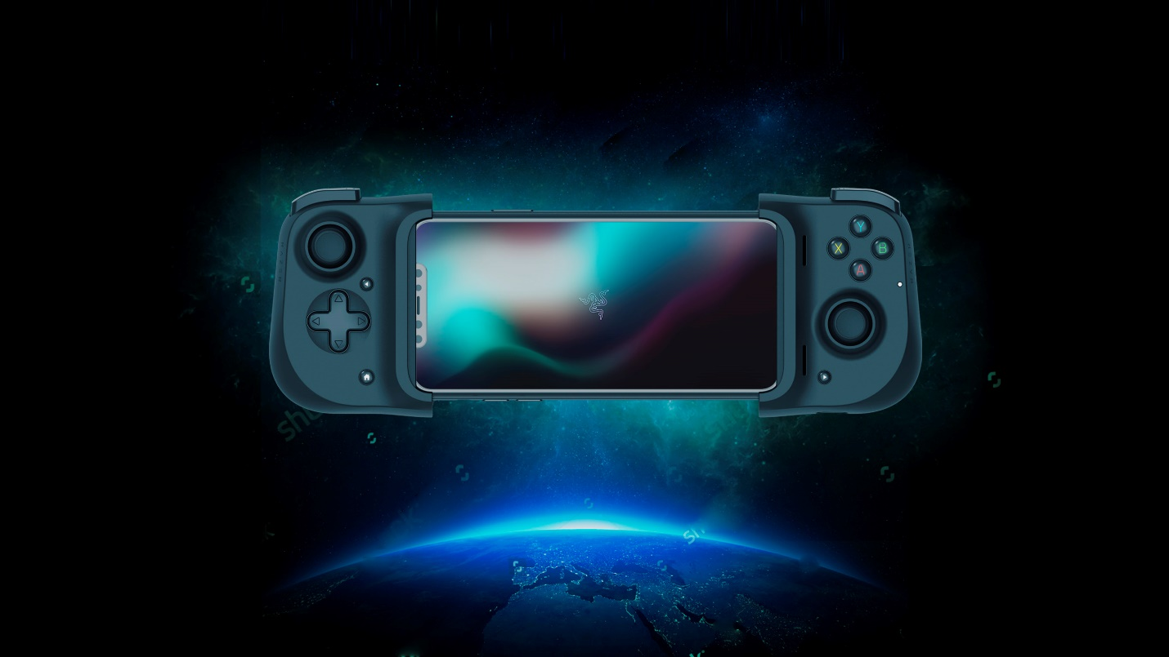

***For Release on January 7, 2020 at 6am PT / 3pm CET / 10pm SGT:***

**LAS VEGAS (CES 2020)** – Razer™, the leading global lifestyle brand for gamers, today announces the new Razer Kishi universal mobile gaming controllers, the Razer Sila 5G Home Router, the Razer Tomahawk Gaming Desktop, and a new Razer Eracing Simulator concept created in collaboration with several game publishers and technology vendors.

At Razer’s CES booth (#21000), visitors are invited to enjoy a dedicated cloud gaming experience zone including a preview of NVIDIA’s GeForce NOW cloud gaming, check out Razer’s industry-leading gaming systems including the new modular, ultra-compact gaming desktop, and participate in a three-lap challenge on the Razer Eracing Simulator.

For more details about Razer’s CES 2020 highlights, please read on.

**PAVING THE WAY FOR HIGH-PERFORMANCE CLOUD GAMING**

As the undisputed innovation leader in gaming hardware, software and services, Razer is looking to get players ready for the future of cloud and mobile gaming. With a view to creating a unique ecosystem of high-performance input devices and infrastructure solutions, the company introduces the Razer Kishi, a universal cloud-gaming compatible controller for iOS and Android phones, and the Razer Sila 5G Home Router, the first gaming-focused 5G router.

The **Razer Kishi universal mobile gaming controllers** support low latency gameplay on either Android or iOS devices. Building on the compact ergonomic form of the Razer Junglecat which primarily targeted Razer Phone 2 owners, Razer’s new Kishi cloud-compatible controllers provide clickable analog controls and thumbsticks on both sides of the phone with a universal fit created in partnership with Gamevice for compatibility with most smartphones.

Ultra-low latency native and cloud game control is now delivered through a hidden USB-C or Apple Lightning® connection, and pass-through charging ports on the Kishi allow for device charging during game play. The Kishi for Android offers support for most Android or iOS games that are compatible with mobile controllers, including both native titles and cloud services.

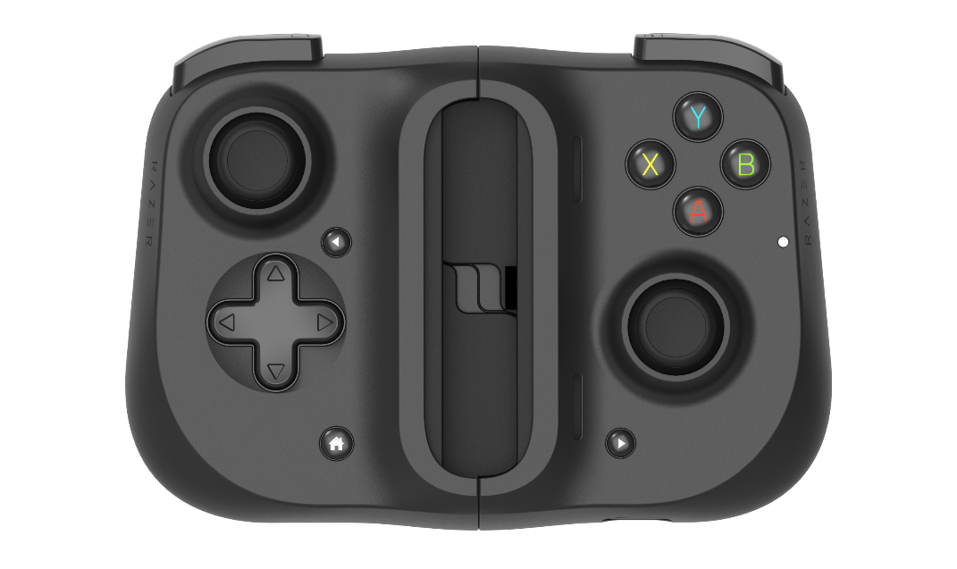

“Razer is excited to strengthen its collaboration with NVIDIA by joining their GeForce NOW Recommended program,” said Jason Schwartz, Head of Mobile Gaming at Razer. “GeForce NOW is PC gaming in the cloud, transforming underpowered or incompatible hardware into a powerful GeForce gaming PC. Razer mobile gaming controllers are perfect complementary devices to enhance this type of gameplay which we are pleased to feature here at the Razer CES booth.”

The Razer Kishi mobile controllers (for Android or iOS) will be available in early 2020.

Razer’s **Sila 5G Home Router** concept is a high-speed networking device tailored for gamers to offer ultra-low latency during both stationary and mobile gameplay, featuring Razer’s proprietary FasTrack engine. A built-in rechargeable battery also adds capability as a mobile 5G hotspot for impromptu, latency-free tournaments wherever you go.

Razer’s FasTrack engine is an intelligent, continuously adaptive QoS (quality of service) feature that prioritizes bandwidth for applications and devices for high-speed gaming & streaming. A unique Gaming Mode allows for online gameplay with no interruptions.

The Razer Sila 5G Home Router lets users prioritize between client hardware, such as Xbox or desktop PC, and is designed to optimize cloud gaming services. Additionally, a manual indicator will notify users when the priority has changed so that they’re always in-the-know.

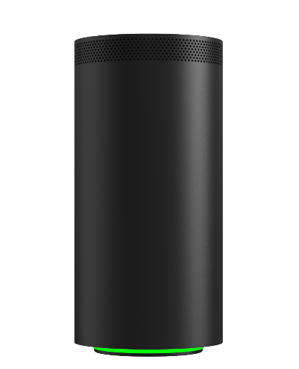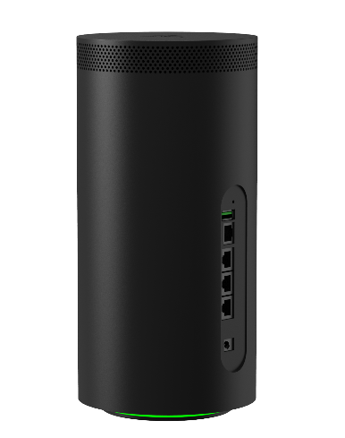

The router can be easily controlled through the available Android or iOS apps with the option to prioritize individual apps or games, or alternatively, to prioritize the categories of those apps. The accompanying app allows users quick and easy control of guest networks, to set security protocols, or adjust device priorities.

**REDEFINING COMPACT GAMING SYSTEMS**

In partnership with Intel®, Razer introduces the **Razer Tomahawk Gaming Desktop** – the first truly modular desktop system utilizing the new ultra-compact Razer Tomahawk N1 chassis.

A perfect fit for the Intel® NUC 9 Extreme Compute Element, the Razer Tomahawk N1 is a sleek, compact desktop chassis with an advanced modular layout, infusing Razer’s minimalistic design language into a gaming chassis to create a one-of-a-kind desktop case, capable of achieving high clock speeds and framerates without the bulk of a full-sized desktop.

A screen shot of a computer

Description generated with high confidence

The Razer Tomahawk N1’s all-aluminum body is flanked by tempered glass on both sides, highlighting the vertically mounted GPU in all its glory, with an open vent design at the top to maintain cooling performance. The rear features a lock-and-slide sled mechanism that opens with minimal effort, allowing for quick access to internal components without the need for tools.

The Razer Tomahawk Gaming Desktop will feature up to an Intel® Core-i9 processor, 64GB of DDR4 RAM, and NVIDIA™ GeForce RTX™ 2080 Super graphics. Both the RAM and SSD modules on the NUC card will be upgradeable as well as the fans, GPU and NUC itself, to satisfy the needs of the most demanding gamers, streamers, and content creators alike.

The Razer Tomahawk Gaming Desktop will be available in the first half of 2020. The Tomahawk N1 case will be available as a standalone product for hardware-savvy PC enthusiasts looking to build their own compact yet powerful gaming PCs.

With the increasing need for processing power in next-gen games and an ever demanding user base, Razer will also launch the **next generation of Razer Blade gaming laptops** later this year. Featuring the latest 10th Gen Intel® Core™ H-Series Processors to meet those expectations, they will pack up to 300Hz refresh rate panels, powerful graphics processors, and optimized designs to stay ahead of the game.

**TAKING POLE POSITION IN NEW ERACING ESPORTS CATEGORY**

For the **Razer Eracing Simulator concept**, Razer brought together some of the leading companies in sim racing to deliver the most immersive racing experience to date, offering a preview and demo of the future of competitive eracing. Running Project CARS Pro, the concept model features technology from Vesaro, Simpit, Fanatec and Synthesis VR, creating a thrilling and immersive eracing setup with a 202-degree projection system, a hydraulic racing platform, full manual controls, and a steering wheel with paddle shift.

The simulator chassis is built with an ultra-strong hand-crafted center core designed around an advanced modular upgrade system, allowing for many simulation scenarios. The center core sits on a motion platform powered by two actuators and a gaming control box for a professional racing training setup that maps terrain surfaces, G-force and sounds into motion for a completely immersive experience. Real surround visuals provided by Simpit come from two Full-HD projectors beaming onto a 128-inch custom black projection surface with 202-degree field-of-view with vibrant colors and deep blacks.

Driver controls from Fanatec feature an anodized aluminum and carbon fiber steering wheel sheathed in smooth leather, magnetic paddles and adjustable buttons for gear shifting and precise driver aide, paired to a three-pedal system below. The racing harness simulates the effects of G-forces by applying pressure, allowing the body to feel the fast acceleration speeds and tightest corners.

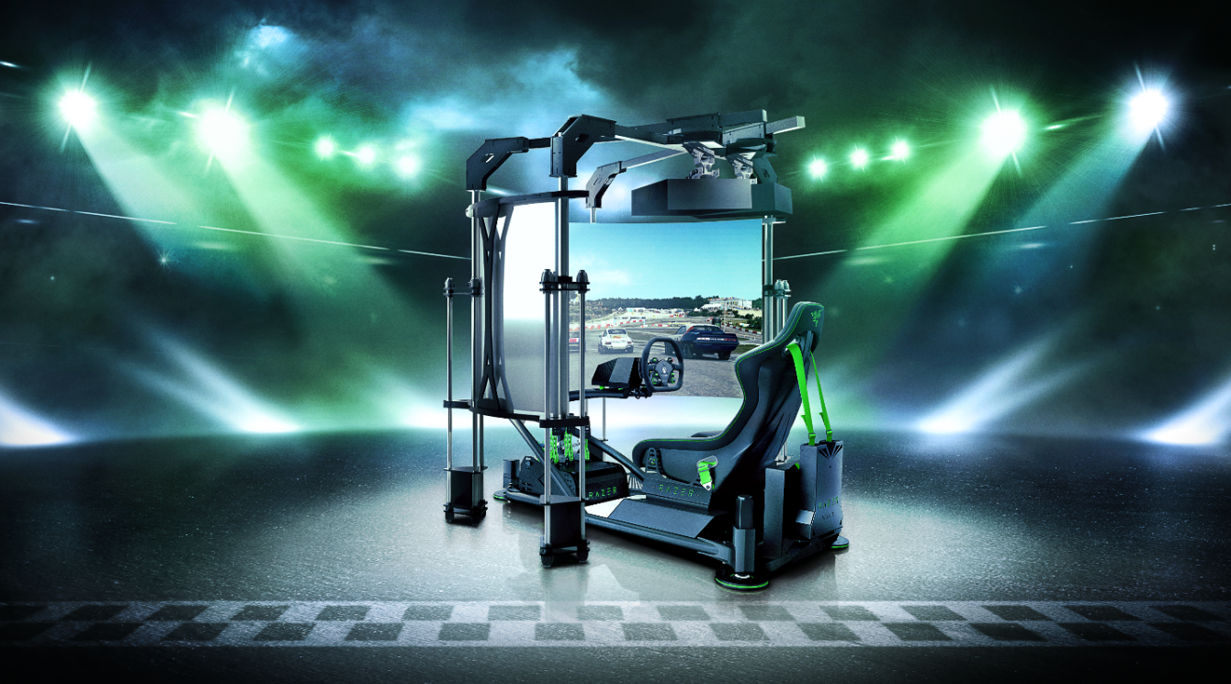

“The competitive eracing scene is an untapped but growing sector of esports for which Razer has brought a new innovation, making the games more enjoyable, more immersive and more exciting for fans,” says David Tse, Global Esports Director at Razer. “We are ready to invest resources into growing this area of competition.”

“We are very excited to be working alongside Razer as they enter the racing esports space at CES 2020; combining one of our professional grade systems with Razer's racing sim effort, we can't wait to see how this will push virtual racing further into the mainstream spotlight and take the sport to the next level,” says Nevil Slade, CEO & Designer for Vesaro.

Razer will continue to develop and build the ultimate eracing simulator, rallying together the best hardware and software technology companies in the industry. Razer will also invest in eracing competitions and leagues in the near future. Parties interested in collaborating on the development of the simulator can contact -knip-.

**ABOUT THE RAZER KISHI MOBILE GAMING CONTROLLERS**

* USB-C or Apple Lightning™ connection
* Android smartphones: Samsung Galaxy S8/S8+/S9/S9+/S10e/S10/S10+/Note 8/Note 9/Note 10/Note 10+, Google Pixel 2/2 XL/3/3XL/4/4XL, and other Android 7.0 Nougat or higher devices
* iOS Smartphones: iPhone 11/11 Pro/11 Pro Max, iPhone XR/XS/XS Max, iPhone X, iPhone 8/8 Plus, iPhone 7/7 Plus, iPhone 6s/6s Plus, iPhone 6 / 6 Plus
* Pass through charging
* Latency-free connectivity

**ABOUT THE RAZER SILA 5G HOME ROUTER**

* Qualcomm SDX55 + Hawkeye IPQ8072A
* 5G NR (Sub-6 and mmWave), and 4G LTE
* Wi-Fi 6 802.11ax 4x4
* 1 x 2.5Gbps WAN, 4 x 1Gbps LAN, 1 x USB 3.0 port
* 1 x SIM slot

**Mesh Node Specifications**

* Qualcomm Atheros IPQ6000
* Wi-Fi 6 11ax 2x2
* 1 x 1Gbps WAN, 4 x 1Gbps LAN, 1 x USB 3.0 port

**ABOUT THE RAZER TOMAHAWK GAMING DESKTOP**

Intel NUC

* Up to Intel 9th Gen i9 8-Core CPU
* Up to 64GB DDR4
* Dual M.2 SSD Slots
* Wi-Fi 6

Graphics

* NVIDIA® GeForce RTX™ 20 Series, Support for full-length PCI graphics cards

Design

* Toolless design
* Compact footprint
* Open vents for efficient cooling

Ports

* 2x Thunderbolt 3, 2x 1G Ethernet, 2x HDMI 2.0A, 6x USB 3.2 Gen 2